Ex.no:4 | EXPLORATORY DATA ANALYSIS (EDA) – DATA INSPECTION, FILTERING, STATISTICAL ANALYSIS AND CORRELATION

Aim:
To perform data inspection, filtering, grouping, aggregation, descriptive statistical analysis, and correlation analysis using Pandas and visualize the results using Matplotlib.
Algorithm:
- Import the required Pandas, NumPy and Matplotlib libraries.
- Read the stud_data.csv file using Pandas.
- Display the dataset and inspect the first few records.
- Find the number of rows and columns and display the data types.
- Generate the statistical summary of the dataset.
- Filter the students based on marks and attendance conditions.
- Sort the student records based on marks and attendance.
- Group the data based on department and calculate average marks and attendance.
- Calculate mean, median, minimum, maximum and standard deviation of marks.
- Calculate the correlation between marks and attendance.
- Create bar chart, line chart, scatter plot, histogram and box plot using Matplotlib.
- Display the results and interpret the obtained data.

Program:
# Import libraries
import pandas as pd
import numpy as np
import matplotlib.pyplot as plt
# Read dataset
data = {
"Roll No": [101, 102, 103, 104, 105, 106],
"Name": ["Arun", "Bala", "Divya", "Priya", "Ravi", "Karthik"],
"Department": ["CSE", "IT", "CSE", "AI&DS", "IT", "AI&DS"],
"Marks": [85, 78, 95, 90, 72, 88],
"Attendance": [92, 88, 96, 94, 85, 91]
}
df = pd.DataFrame(data)
print(df)
# Display dataset
print(df)
# Display first five records
print(df.head())
# Display shape
print(df.shape)
# Display data types
print(df.dtypes)
# Filter students with marks greater than 85
high_marks = df[df["Marks"] > 85]
print(high_marks)
# Students from IT Department
it_students = df[df["Department"] == "IT"]
print("\nStudents from IT Department:") print(it_students)
#Sort Marks in Descending Order
sorted_df = df.sort_values( by="Marks", ascending=False )
print("\nStudents Sorted by Marks:")
print(sorted_df)
#Visualization 1: Student Marks Ranking
plt.figure(figsize=(8, 5))
plt.bar(sorted_df["Name"], sorted_df["Marks"])
plt.xlabel("Student") plt.ylabel("Marks")
plt.title("Student Marks Ranking")
plt.show()
#Statistical Analysis
print("\nStatistical Analysis:")
print("Mean =", df["Marks"].mean())
print("Median =", df["Marks"].median())
print("Mode =", df["Marks"].mode().tolist())
print("Standard Deviation =", df["Marks"].std())
#Descriptive Statistics
print("\nDescriptive Statistics:")
print(df.describe())
#Grouping and Aggregation
dept_avg = df.groupby("Department")["Marks"].mean()
print("\nDepartment-wise Average Marks:")
print(dept_avg)
# Department-wise Average Marks
plt.figure(figsize=(8, 5))
plt.bar(dept_avg.index, dept_avg.values)
plt.xlabel("Department")
plt.ylabel("Average Marks")
plt.title("Department-wise Average Marks")
plt.show()
#Correlation Analysis
corr = df[["Marks", "Attendance"]].corr()
print("\nCorrelation Matrix:")
print(corr)
#Marks vs Attendance
plt.figure(figsize=(8, 5))
plt.scatter(df["Attendance"], df["Marks"])
plt.xlabel("Attendance")
plt.ylabel("Marks")
plt.title("Marks vs Attendance Relationship")
plt.show()

Output:
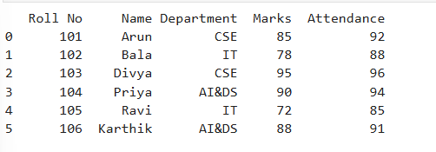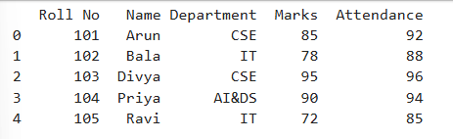

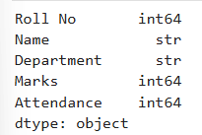
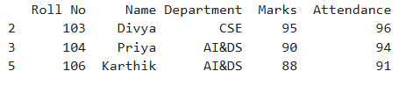
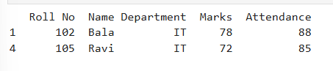
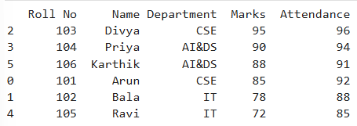
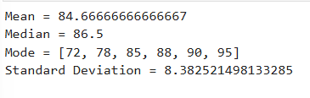
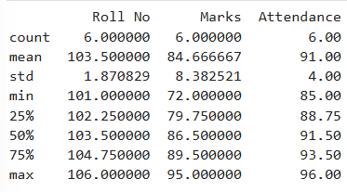
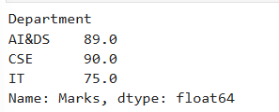
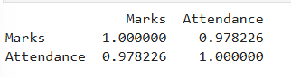
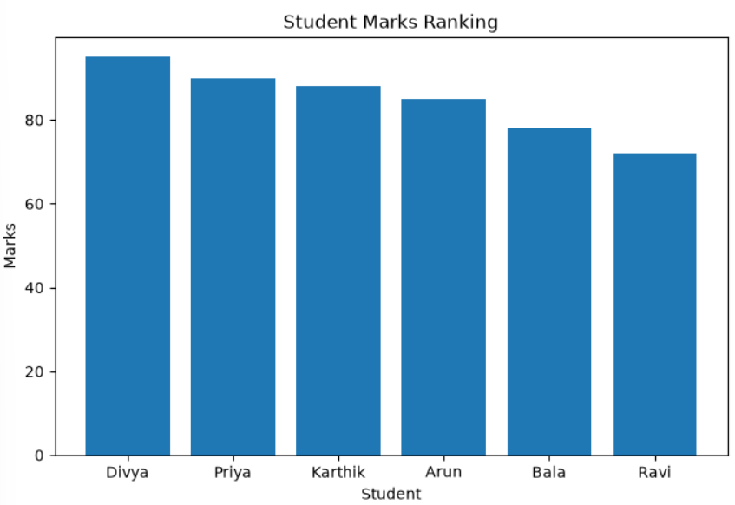
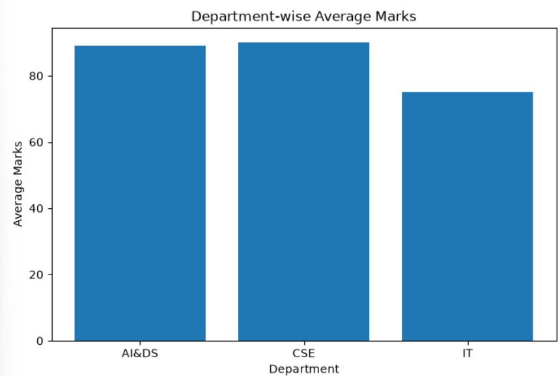
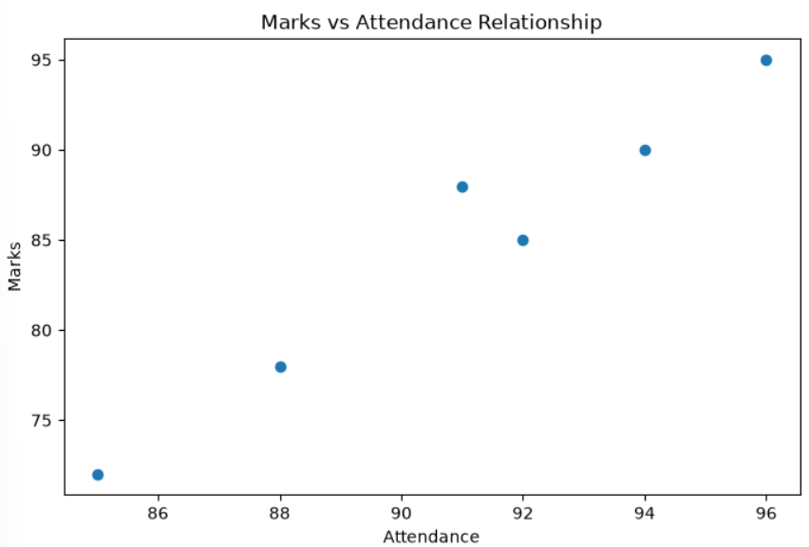Result:

